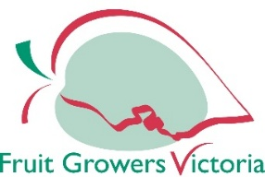
FRUIT GROWERS VICTORIA LTD.
APPLICATION FOR GROWER MEMBERSHIP

First Name Last Name
Company Name

Postal Address (Please include Postcode)

Residential Address (Please include Postcode)

Telephone Contact Details

Business Hours After Hours

Mobile Fax
Email address

Accounts Contact & Email address

VARIETIES NUMBER OF HECTARES

APPLES

PEARS

STONEFRUIT

CHERRIES

Total No of Hectares

**Please see reverse side



FRUIT GROWERS VICTORIA LTD.
APPLICATION FOR GROWER MEMBERSHIP

Grower Membership
$250 + $26 per hectare (capped at $2,835) excluding GST

*Former Victorian Cherry Association members will receive a 25% discount on their first three years of membership with Fruit Growers Victoria. This discount will be automatically applied on your invoice.

The above named hereby applies for membership of Fruit Growers Victoria Lid. And agrees to pay the membership fee commensurate with the grower membership.

Signature Date

Please forward this Membership Application to info@fgv.com.au and an invoice will be sent to you for payment.

